H.T No
Regulations:
A17

Sreenidhi Institute of Science and Technology
(An Autonomous Institution)
Code No: 6K502 Date: 05-Oct-2021(FN)

B.Tech III-Year I- Semester External Examination, Sept/Oct - 2021 (Supplementary)
Structural Analysis - II (CIVIL)

Time: 3 Hours Max.Marks:75

Note: a) No additional answer sheets will be provided.
b) All sub-parts of a question must be answered at one place only, otherwise it will not be valued.
c) Missing data can be assumed suitably.

ANSWER ANY 5 OUT OF 8 QUESTIONS. EACH QUESTION CARRIES 15 MARKS.

Bloom's Cognitive Levels of Learning (BCLL)

Remember | L1 | Apply | L3 | Evaluate | L5
Understand | L2 | Analyze | L4 | Create | L6

 |  |  | BCLL | CO(s) | Marks
1. |  | A uniform load of 40 kN/m run, 6 m long crosses a girder of 30 m span. Calculate the maximum shear force and bending moment at a section 5, 10, and 15 m from the left hand support.Construct the maximum shear force and bending moment diagrams. | L3 | CO1 | [15M]
2. | a) | A three-hinged parabolic arch hinged at the supports and at the crown has a span of 24 m and a central rise of 4 m. It carries a concentrated load of 50 kN at 18 m from left support and a uniformly distributed load of 30 kN/m over the left half portion. Determine the moment, thrust and radial shear at a section 6 m from the left support. | L4 | CO2 | [8M]
 | b) | A two hinged parabolic arch of span L and rise ‘L/4’ subjected to a concentrated load ‘W’ at quarter point. Determine the horizontal thrust. | L2 | CO2 | [7M]
3. |  | A foot bridge of width 3m and span 50m is carried by two cables of uniform section having a central dip of 5m. The platform load is 5kN/m². Calculate the maximum pull in the cable and also find the necessary section area required if the allowable stress is 120N/mm². | L3 | CO3 | [15M]
4. |  | Analyze the continuous beam shown in fig. using flexibility method.  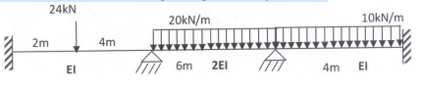 | L4 | CO4 | [15M]
5. |  | Analyze the continuous beam by stiffness method? Assume EI is constant. Draw B.M.D.  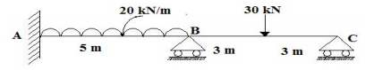 | L4 | CO5 | [15M]
6. | a) | Discuss in detail how the plastic hinge and mechanisms are formed by citing one example. | L2 | CO6 | [8M]
 | b) | A beam fixed at both ends is subjected to a uniformly distributed load w/m run over the right half portion of the beam. Determine the value of collapse load. The beam is of uniform plastic moment Mp. | L3 | CO6 | [7M]
7. | a) | Derive an expression for horizontal thrust in a two hinged arch? | L4 | CO1 | [8M]
 | b) | A suspension cable is supported at two points 25 m apart. The left support is 2.5 m above the right support. The cable is loaded UDL of 10kN/m throughout the span. The maximum dip in the cable from left support is 4m. Find the maximum and minimum tension in the cable. | L3 | CO2 | [7M]
8. | a) | Analyze the continuous beam shown in figure by stiffness method and Sketch the BMD.  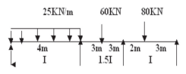 | L4 | CO4 | [8M]
 | b) | Derive shape factor for triangular section | L3 | CO5 | [7M]

-- 00 -- 00 –

